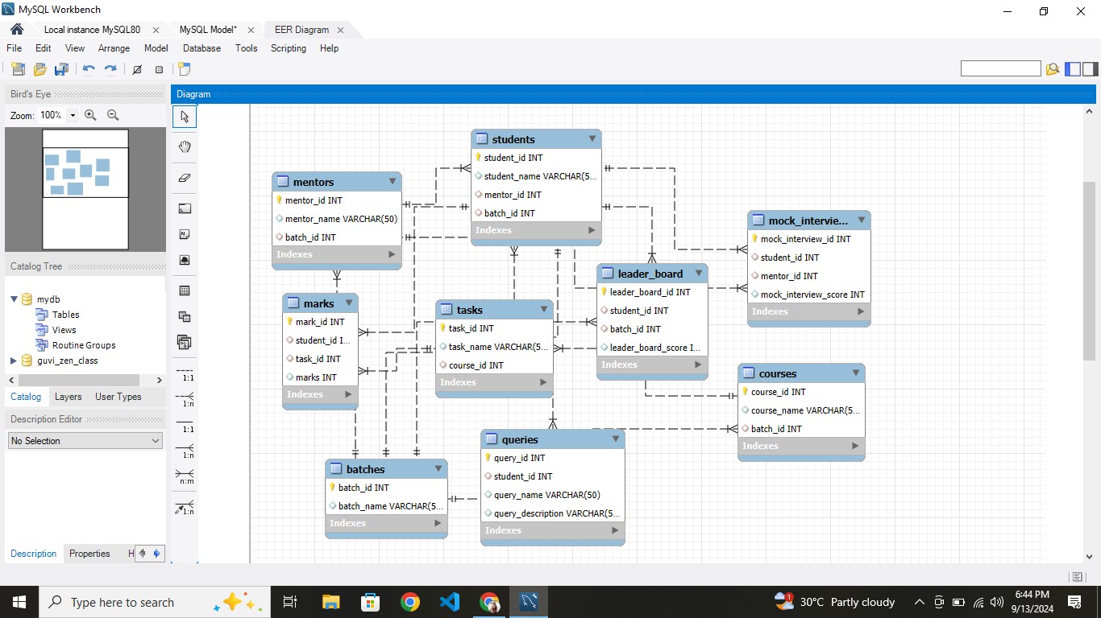

|  |
| --- |
|  |
|  |  |  |
|  |  | create table batches(batch_id int primary key, batch_name varchar(50)); |
|  |  | desc batches; |
|  |  |  |
|  |  | create table mentors(mentor_id int primary key, mentor_name varchar(50), batch_id int, |
|  |  | foreign key (batch_id) references batches(batch_id)); |
|  |  | desc mentors; |
|  |  |  |
|  |  | create table courses(course_id int primary key, course_name varchar(50), batch_id int, |
|  |  | foreign key (batch_id) references batches(batch_id)); |
|  |  | desc courses; |
|  |  |  |
|  |  | create table tasks(task_id int primary key, task_name varchar(50), course_id int, |
|  |  | foreign key (course_id) references courses(course_id)); |
|  |  | desc tasks; |
|  |  |  |
|  |  | create table students(student_id int primary key, student_name varchar(50), mentor_id int, batch_id int, |
|  |  | foreign key (mentor_id) references mentors(mentor_id), foreign key (batch_id) references batches(batch_id)); |
|  |  | desc students; |
|  |  |  |
|  |  | create table marks(mark_id int primary key, student_id int, task_id int, marks int, |
|  |  | foreign key (student_id) references students(student_id), foreign key (task_id) references tasks(task_id)); |
|  |  | desc marks; |
|  |  |  |
|  |  | create table queries(query_id int primary key, student_id int, query_name varchar(50), query_description varchar(50), |
|  |  | foreign key (student_id) references students(student_id)); |
|  |  | desc queries; |
|  |  |  |
|  |  | create table mock_interviews(mock_interview_id int primary key, student_id int, mentor_id int, mock_interview_score int, |
|  |  | foreign key (student_id) references students(student_id), foreign key (mentor_id) references mentors(mentor_id)); |
|  |  | desc mock_interviews; |
|  |  |  |
|  |  | create table leader_board(leader_board_id int primary key, student_id int, batch_id int, leader_board_score int, |
|  |  | foreign key (student_id) references students(student_id), foreign key (batch_id) references batches(batch_id)); |
|  |  | desc leader_board; |